Lab9

You’re asking to create a Ticket booking form looks like the screenshot.

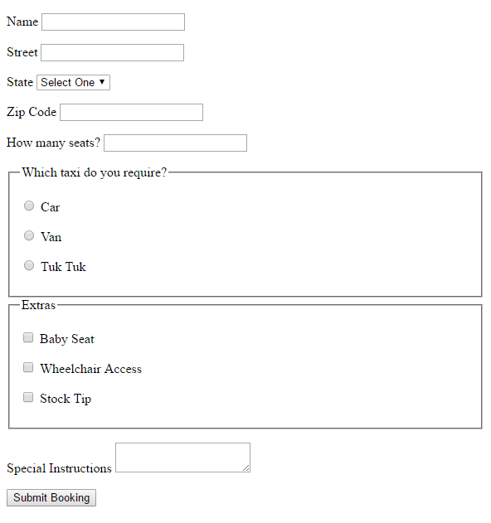

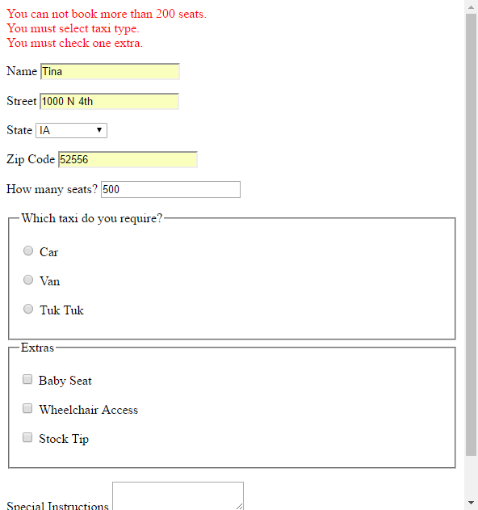

Requirement:

1. All fields except Special Instructions are required.
2. Name must be all letters, at least 1 letter.
3. State is US state, you can just list 3.
4. Zip code must be 5 digit.
5. The seats must be a number, greater than 0 and less than 200. Display errors if not correct as screenshot shows.
6. You’re welcome to practice other validation.
7. For checking seats, radio button and checkbox, you must use jQuery. Other validation, you can use HTML 5.
8. Only all validation pass, submit form.
9. Once you’re done, upload to mumstudents.org, update your home page to include this Lab. Submit your home page link on Sakai.